**User Manual**

The user manual of the project “**Online Book Store**”

The system contains the following interfaces:

**Home Page:**

This page includes the admin, book seller and customer login panel and customer registration panel.

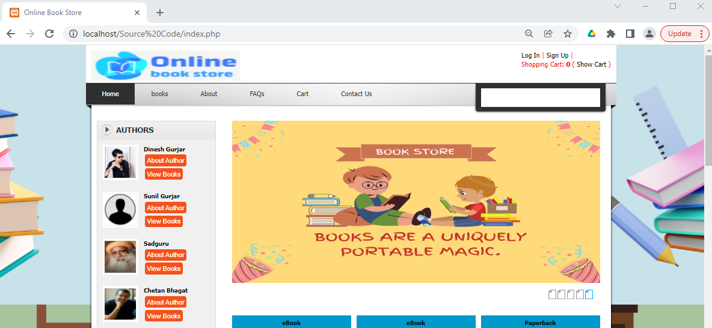



**Admin Login Panel:**

This page includes admin login form where admin can login to the portal by entering login ID and password.

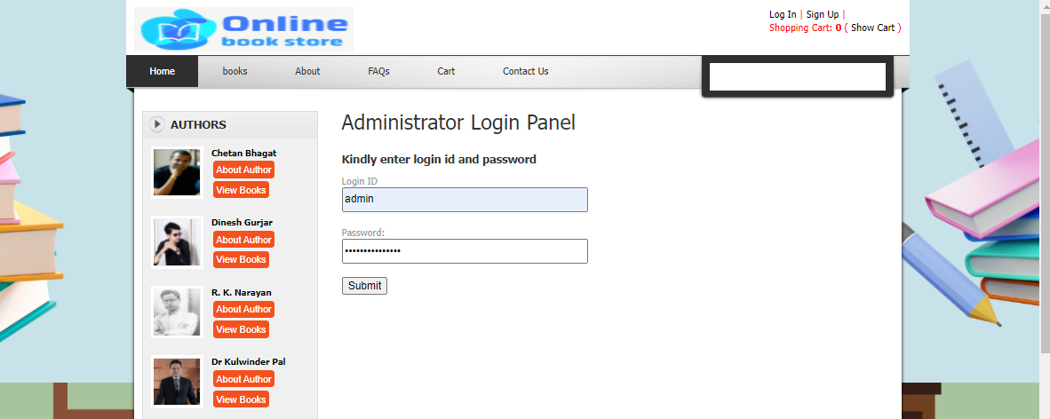

Once the admin logs in admin dashboard is available to view.

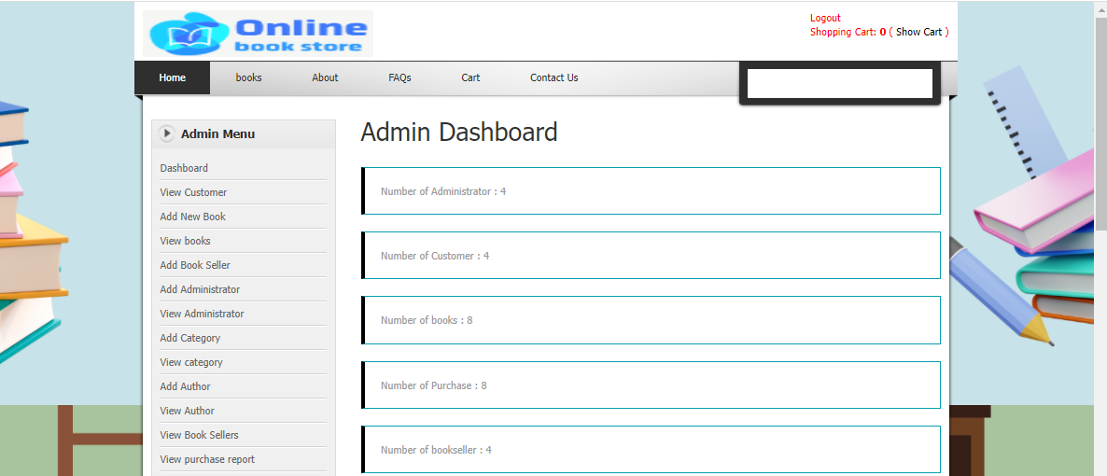

**View Books page:**

In this page admin can view the various categories of books added by the admin and the book sellers.

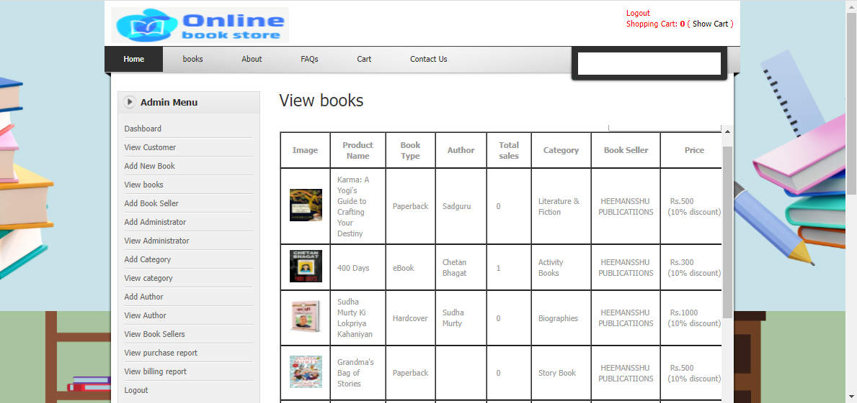

**Add Book Seller Panel:**

In this page, the admin can add the book seller or publishers details.

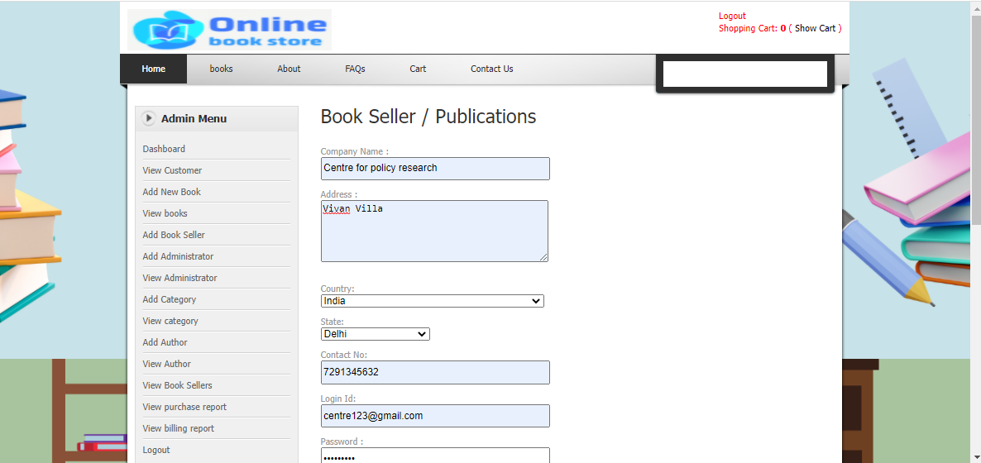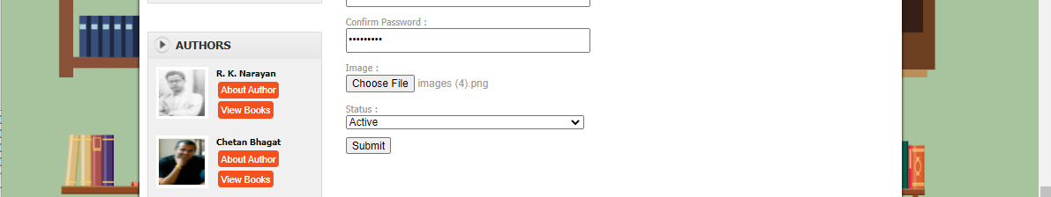

**View Book Seller Panel:**

This page allows the admin to view the book sellers details.

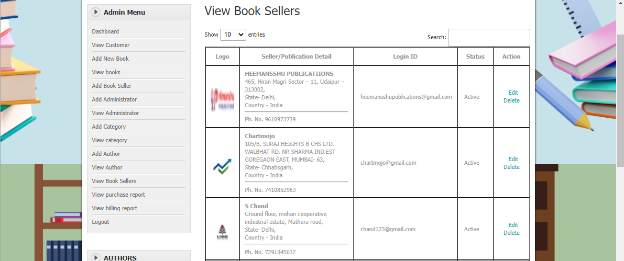

**Category Panel:**

In this page admin can add the various categories of the books.

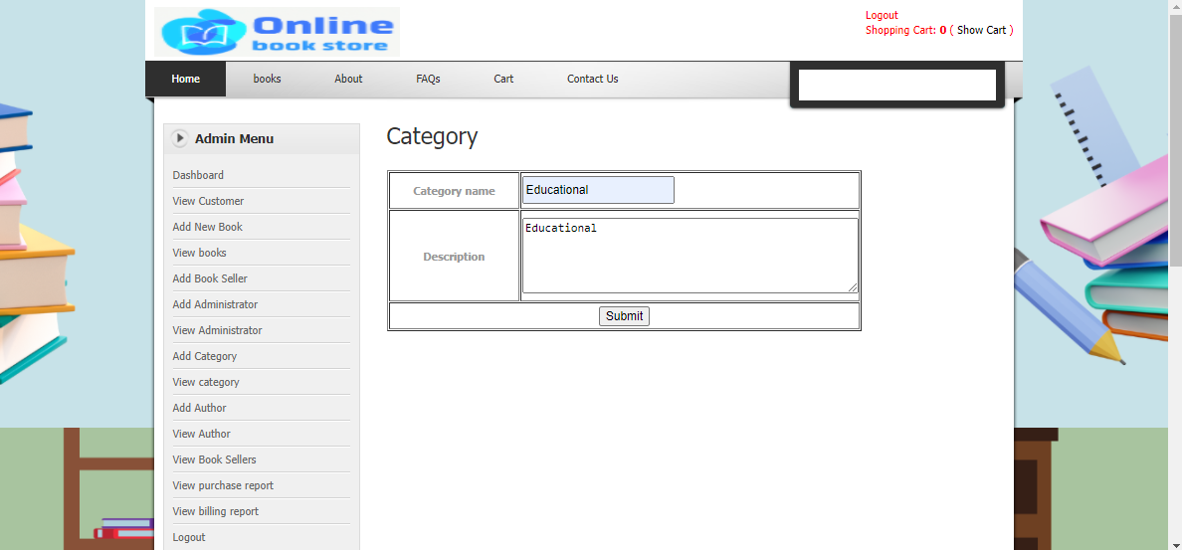

**View Category Panel:**

This page allows the admin to view the various categories. Admin can edit or delete the categories added by them.

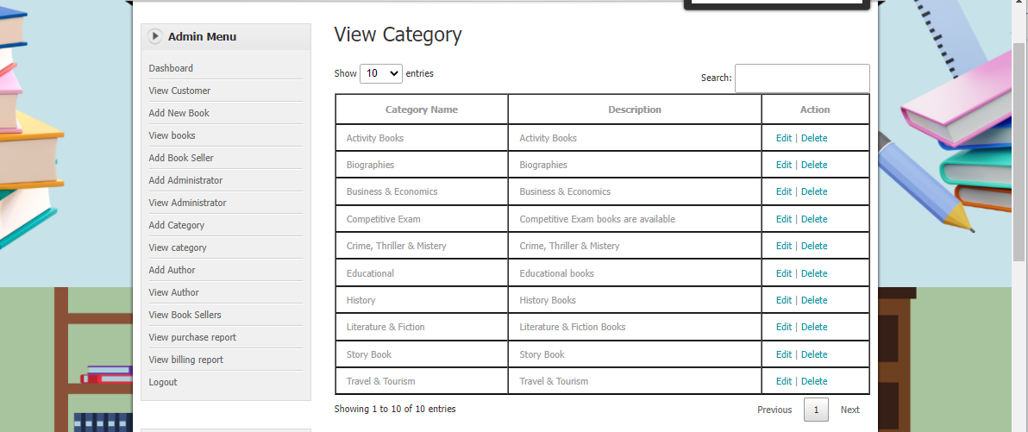

**Author Panel:**

In this page, admin can add the various authors of the books.

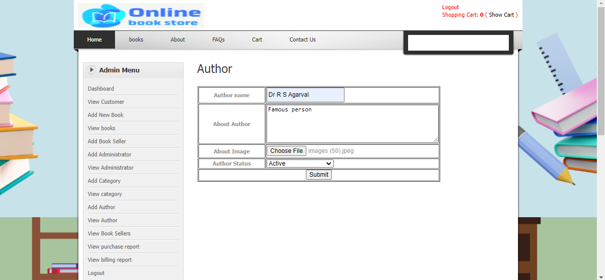

**View Author Panel:**

This page allows the admin to view the authors. Admin can edit and delete the author details.

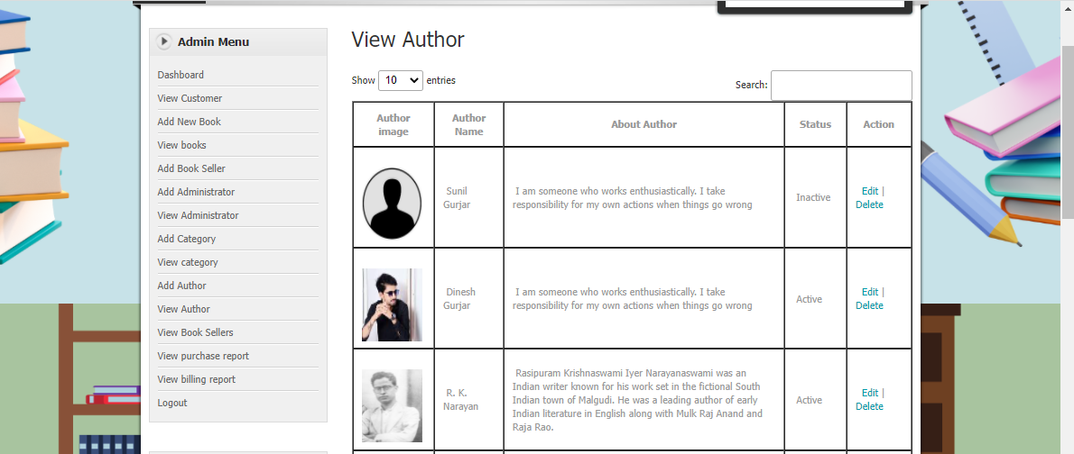

**Purchase Panel:**

The admin can view the book purchase details made by the customers.

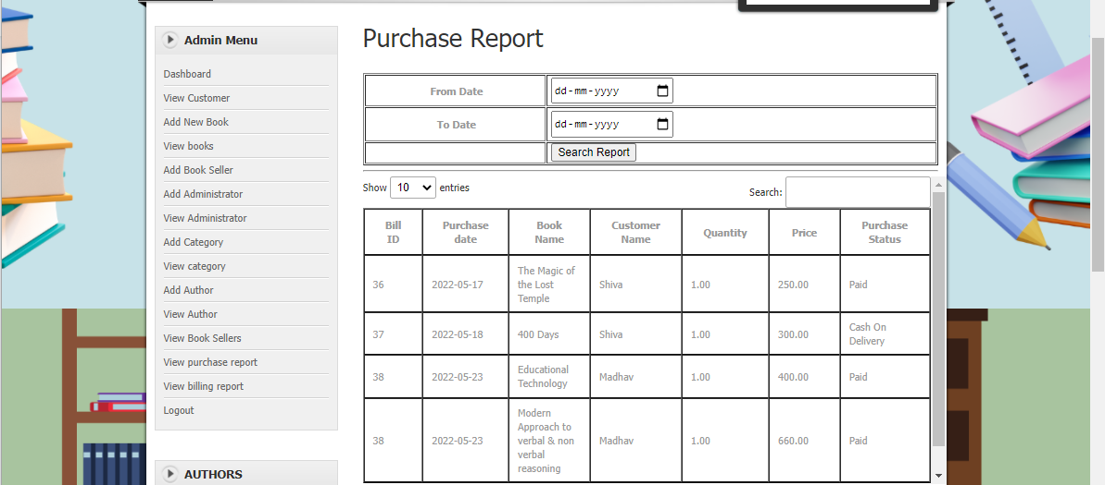

**Billing Panel:**

In this panel, admin can view the billing receipt and delivery details of the books purchased by the customers.

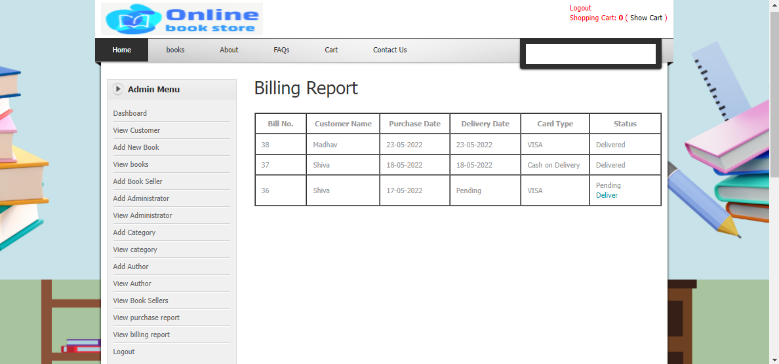

**Book Seller Login Panel:**

In this page, the book seller can login to the website by entering the login credentials provided by the admin.

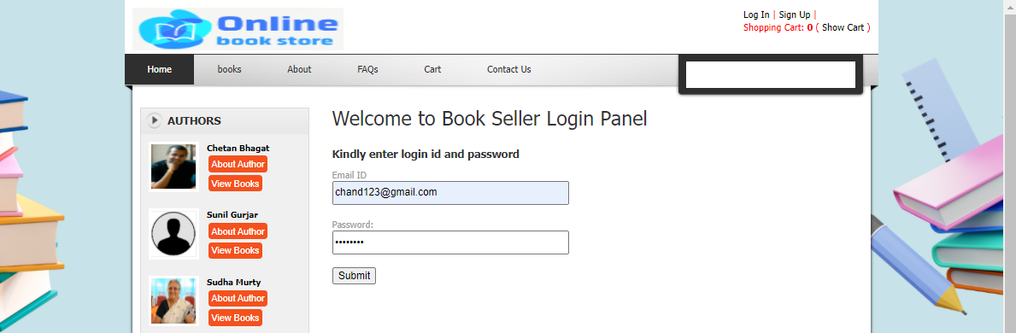

Once the book seller logs in, book seller panel is available to view and they can also view the recent order details.

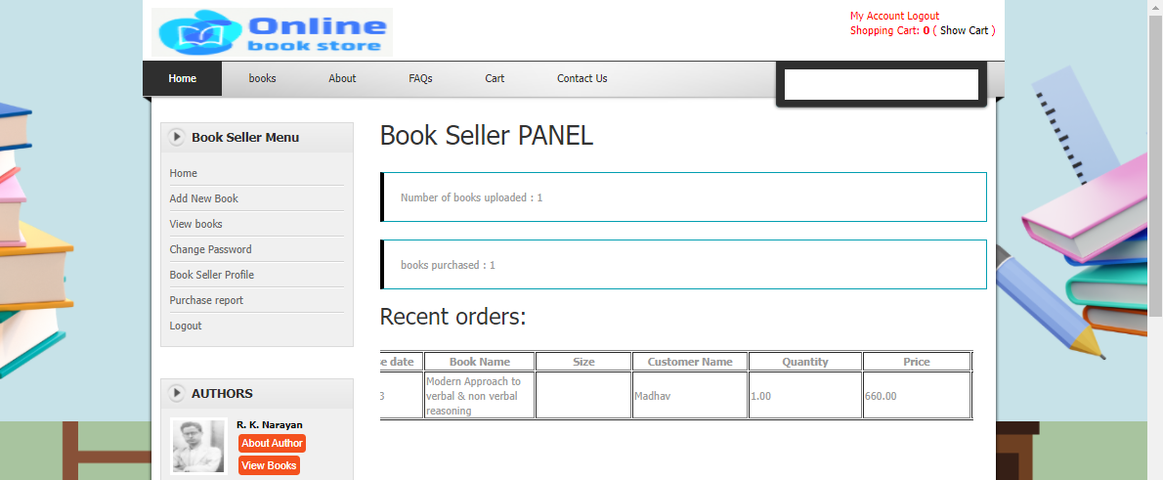

**Add Books Panel:**

In this page, the book seller can add the various books of their publications by selecting different categories and authors.

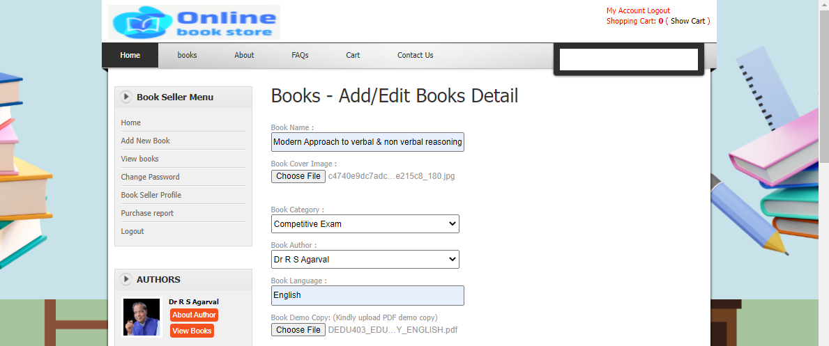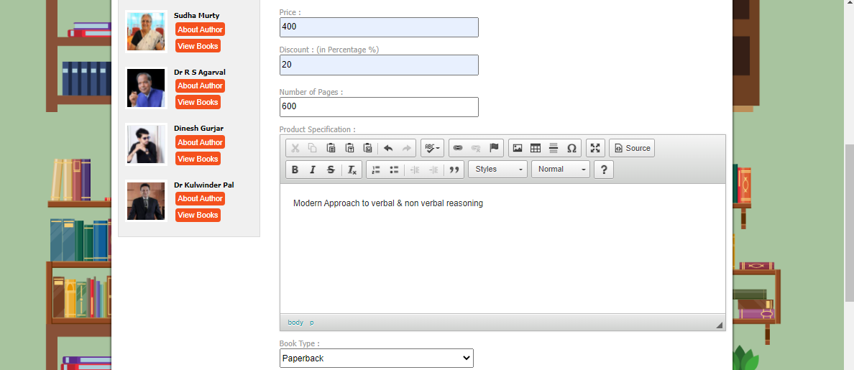

There are three types of books, among which paperback and hardcover are similar and e-book is different from them. This is how the e-book is added by the book seller.

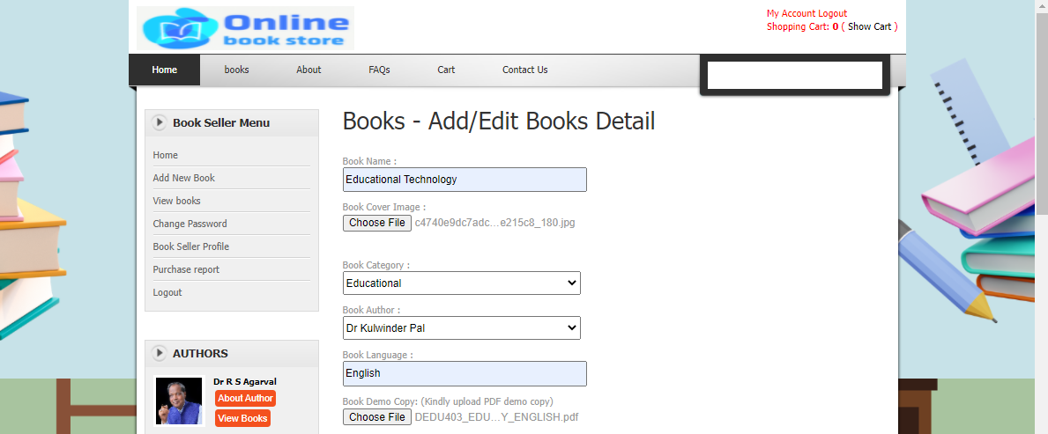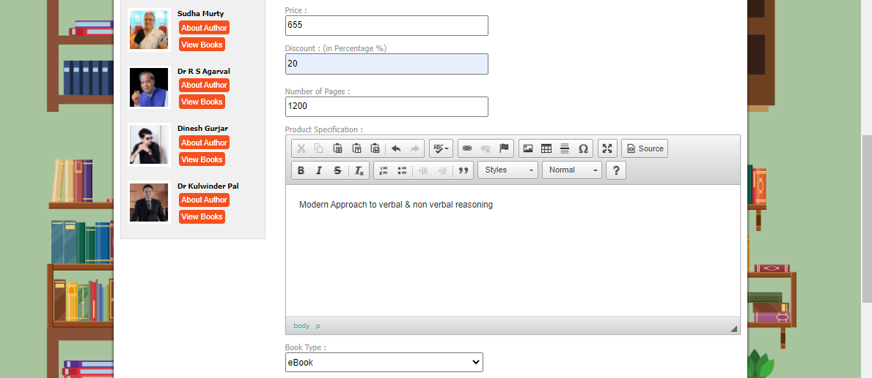

**View Books Panel:**

This page allows the book seller to view the different types of books posted by them.

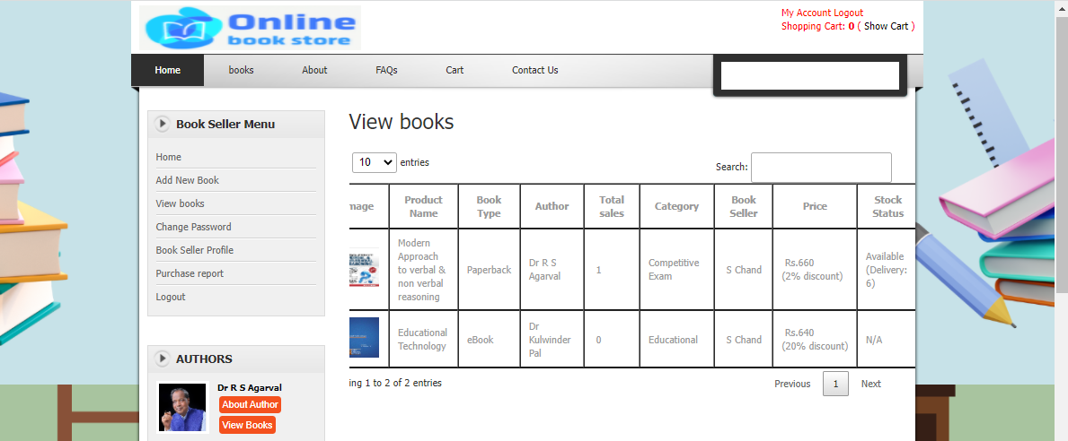

**Purchase Panel:**

Purchase panel allows the book seller to view the purchase details made by the customers.

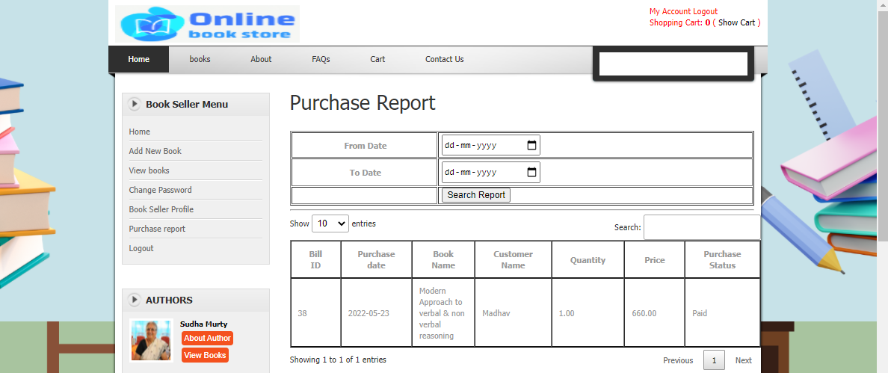

**Customer Registration Page:**

In this page, the Customer must register to portal by entering their personal information.

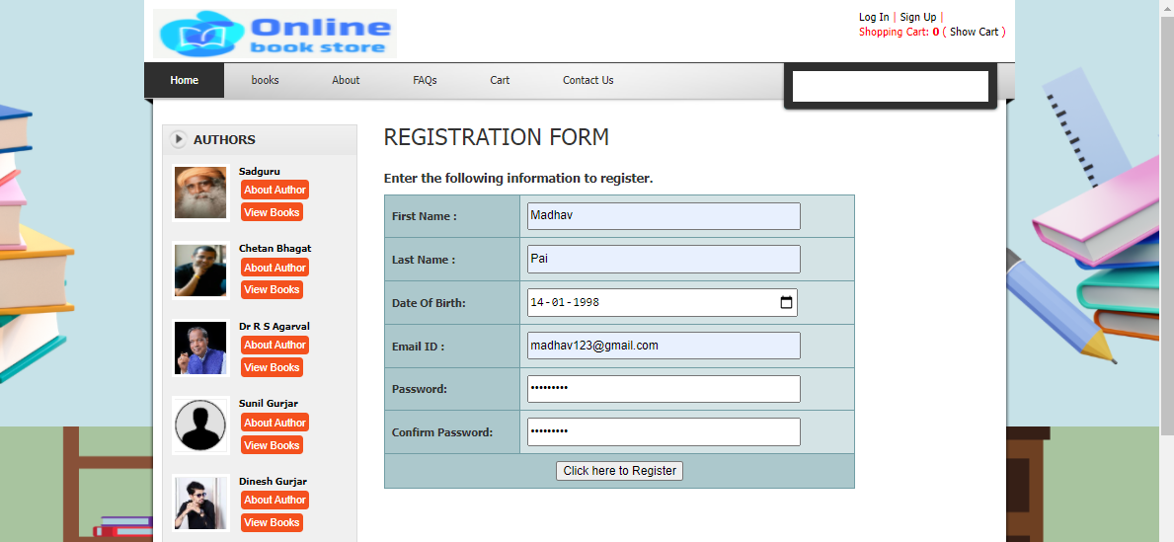

Once the registration is successful, they can login to the website by entering the login credentials provided by them at the time of registration.

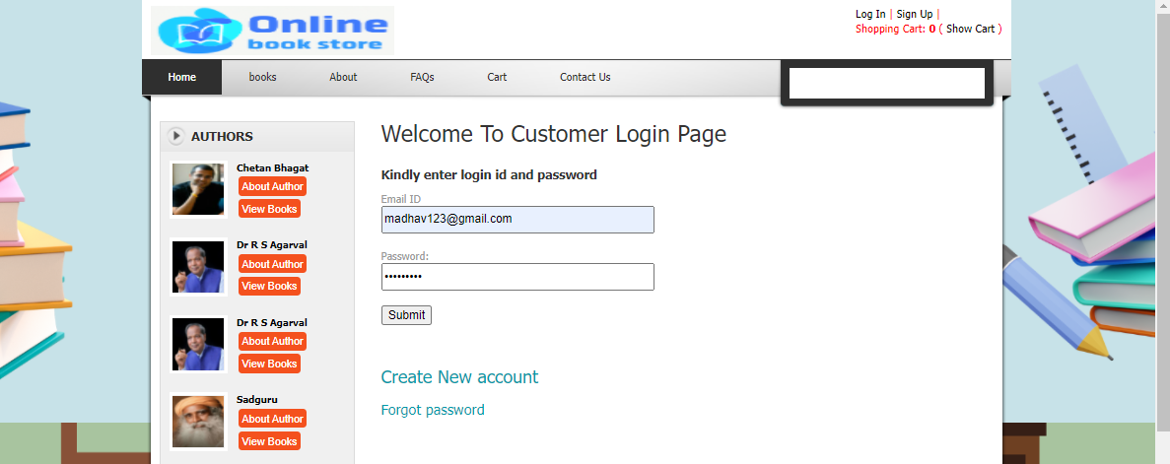

Once the Customer logs in, customer panel is available to view.

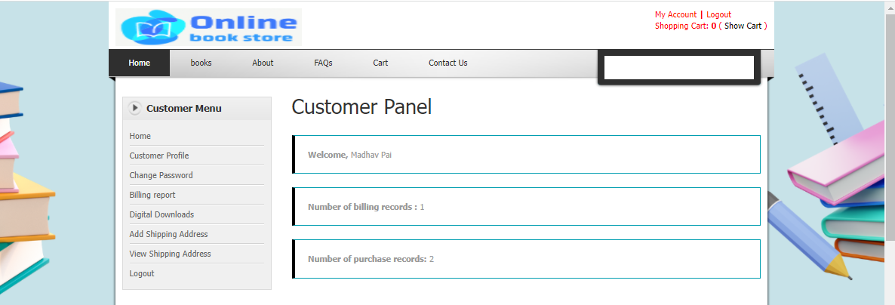

**Customer Profile Update Panel:**

The Customers can update their profile details in this page.

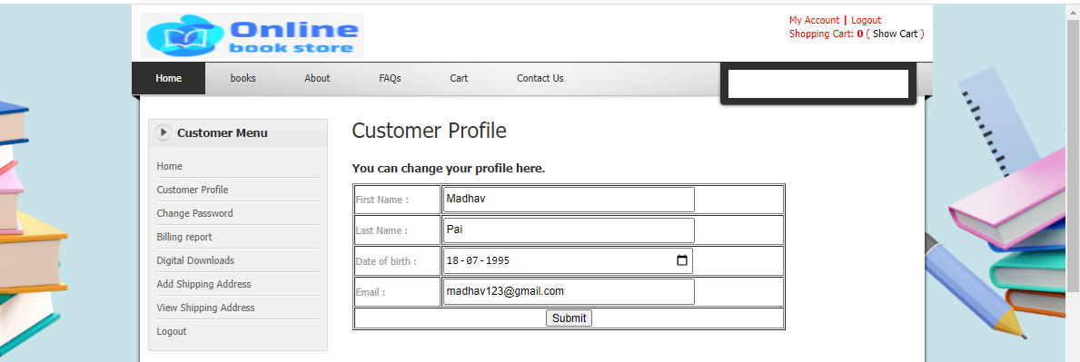

**Customer Change Password Panel:**

This page allows the customer to change their password by entering the email Id, old, new and confirm password details.

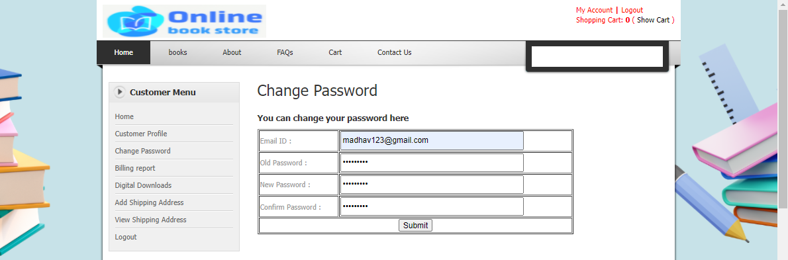

**Books Panel:**

The Customers can view different categories of books in this panel. They can also view the books based on their desired authors.

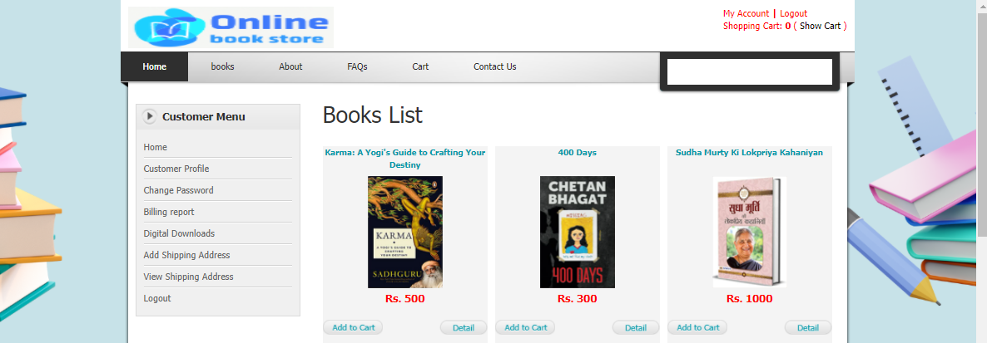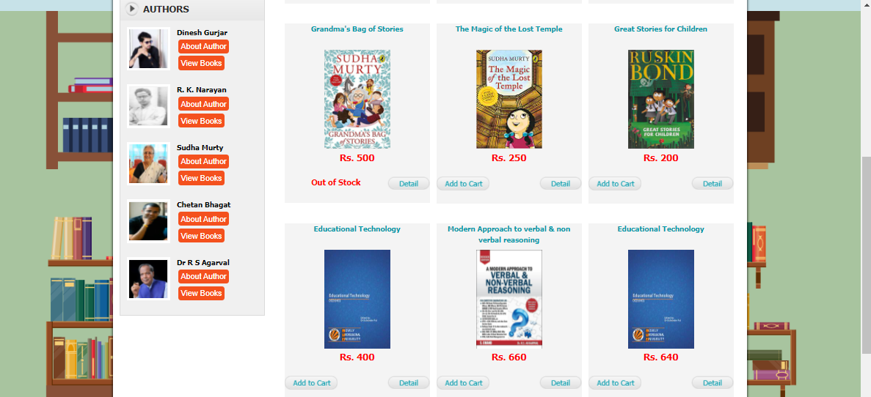

Customers can view the books in detail by clicking on details button. If they wish to buy the book they can add them to cart by mentioning the quantity of books they wish to purchase.

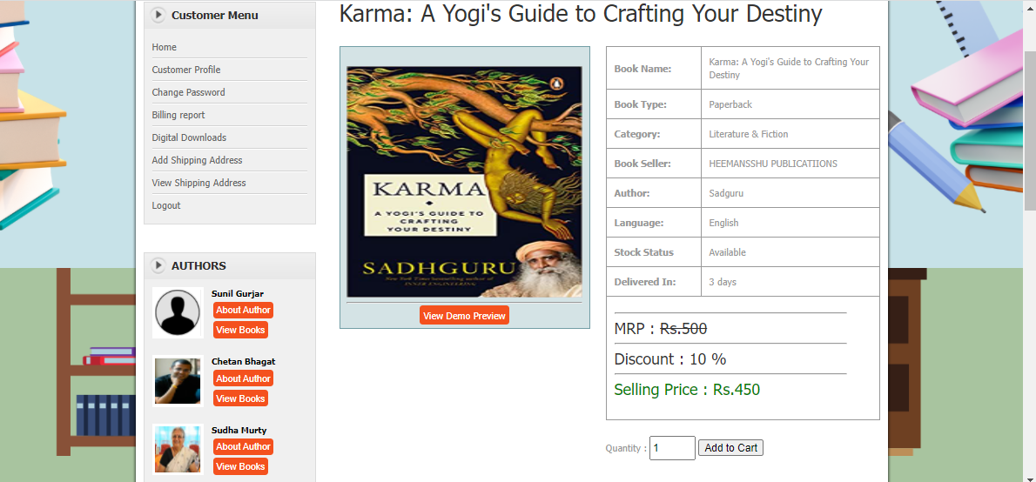

In the cart customers can view their books added to purchase, here they can continue shopping or proceed to checkout.

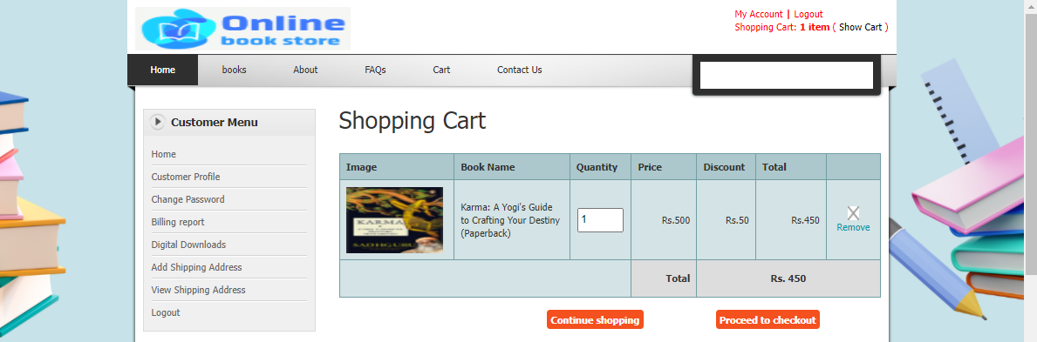

While they proceed to checkout, they must select the shipping address, and the payment details. They can choose either cash on delivery option or card payment.

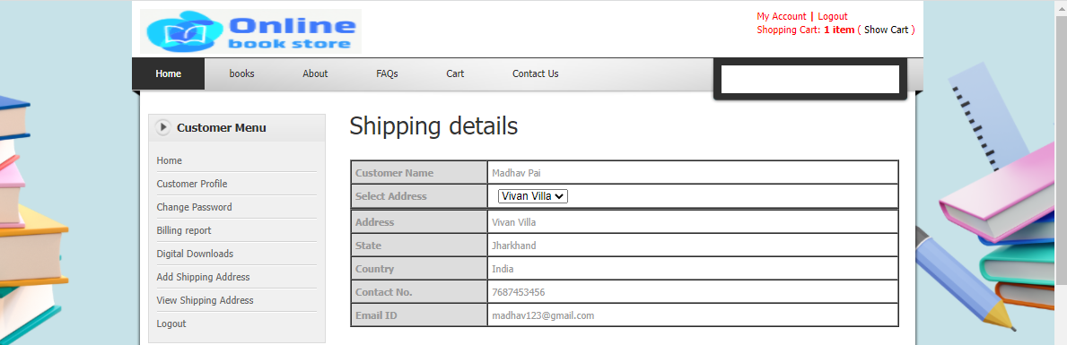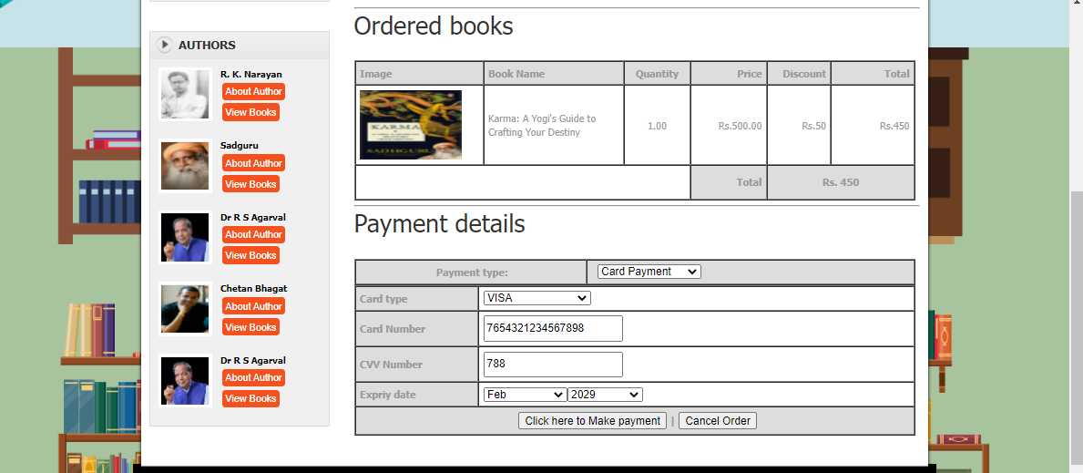

Once the payment is made and order is confirmed, billing receipt is available for the customer which can be printed by them.

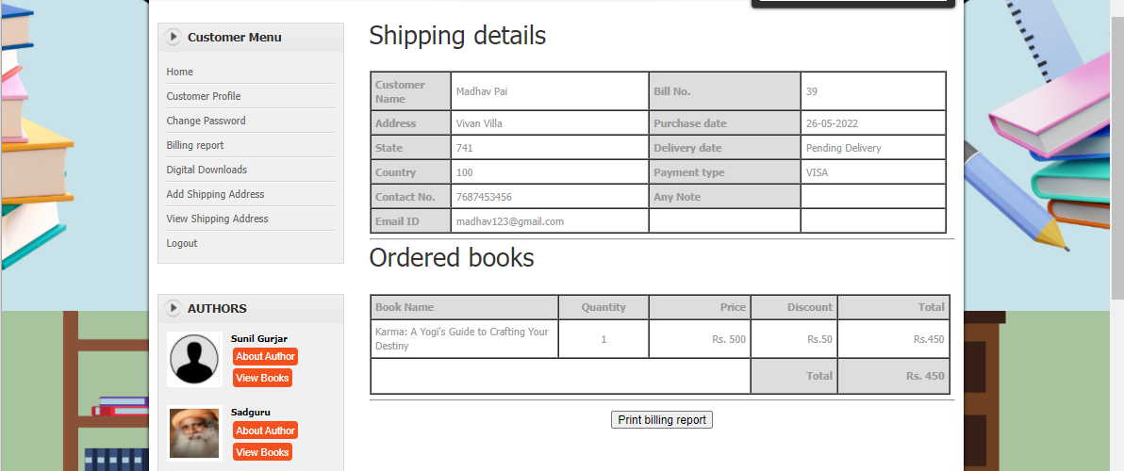

**Billing Report Panel:**

In this page the Customer can view the billing report of their purchases.

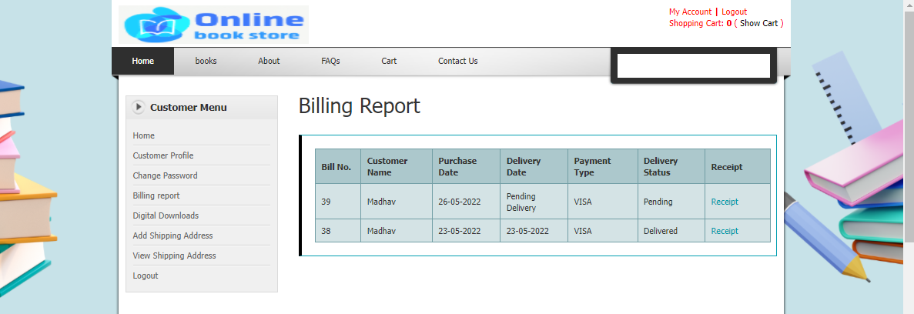

**Digital Downloads Panel:**

If the customer has ordered for a e-book, then it is available for them to download in this page after the payment is complete.

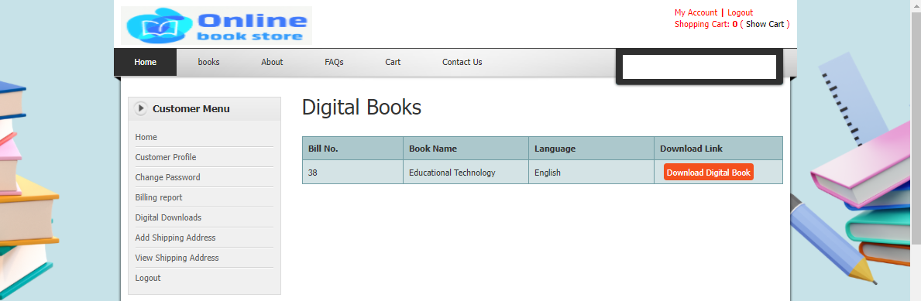

**Add Shipping Address Panel:**

The customer can add more than one shipping address details in this page.

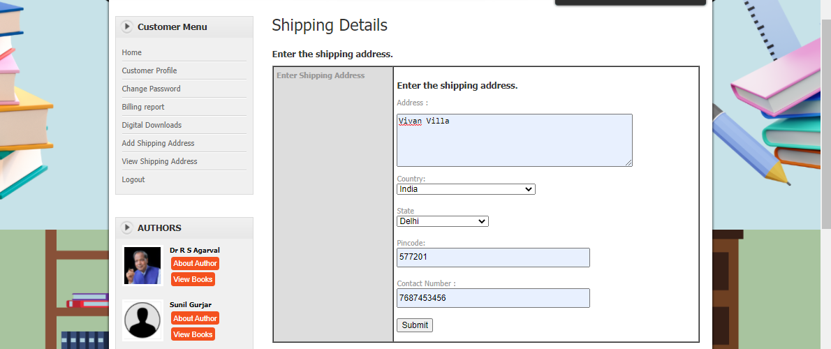

**View Shipping Address Panel:**

This page allows the customers to view the shipping addresses added by them. The customers can also edit or delete the addresses added by them.

